Names: Joshua Singco, Hudson Gordon, Nischal Pandit and Mission Rana

**Assignment 2: RADIUS and Windows Services**

**Windows server**

* Updated contents of the DNS forward lookup zone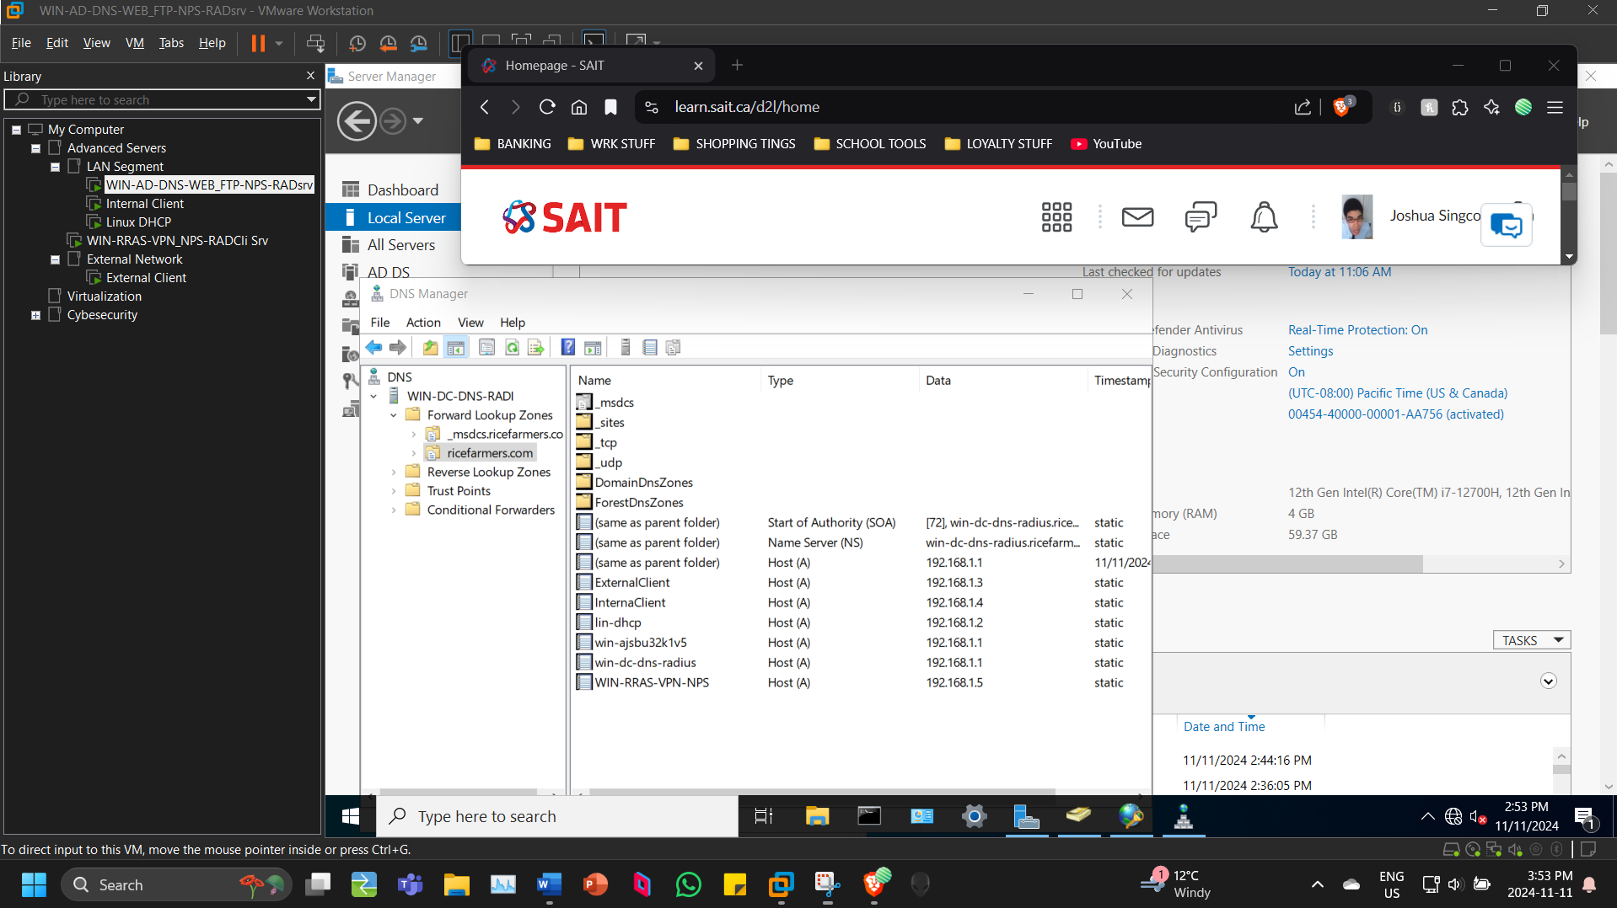
* NPS configuration showing the contents of the radius client, the active network policy, and the connection requests policy. 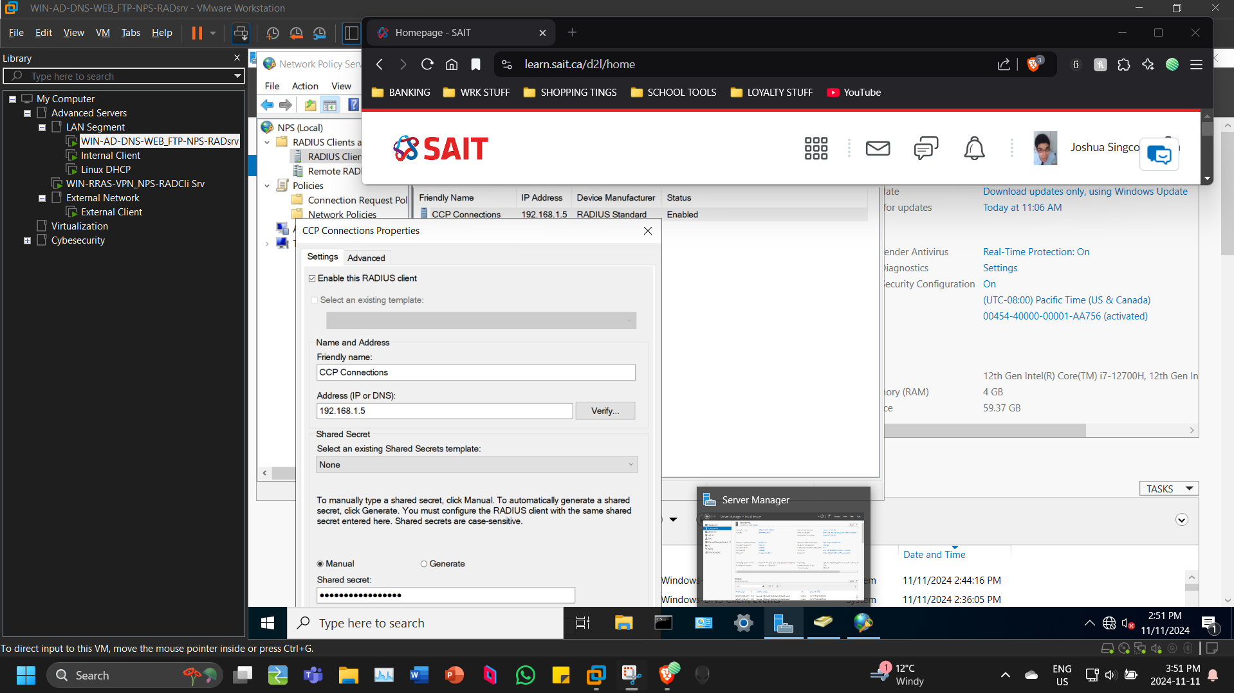
* IIS showing the created FTP and Websites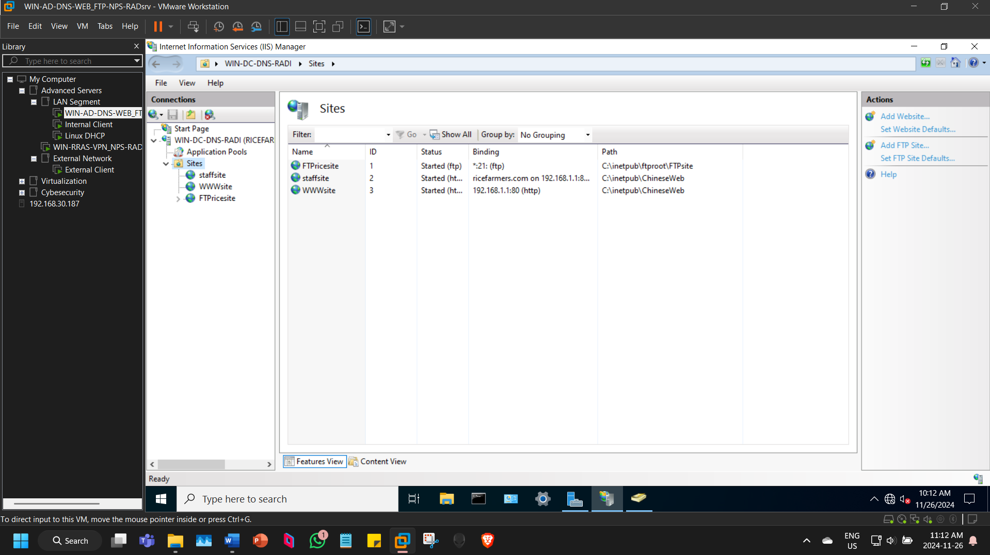

**VPN Server**

* Security tab of RRAS properties, showing the configuration for RADIUS authentication and accountingA screenshot of a computer

  Description automatically generated
* Show port forwarding configuration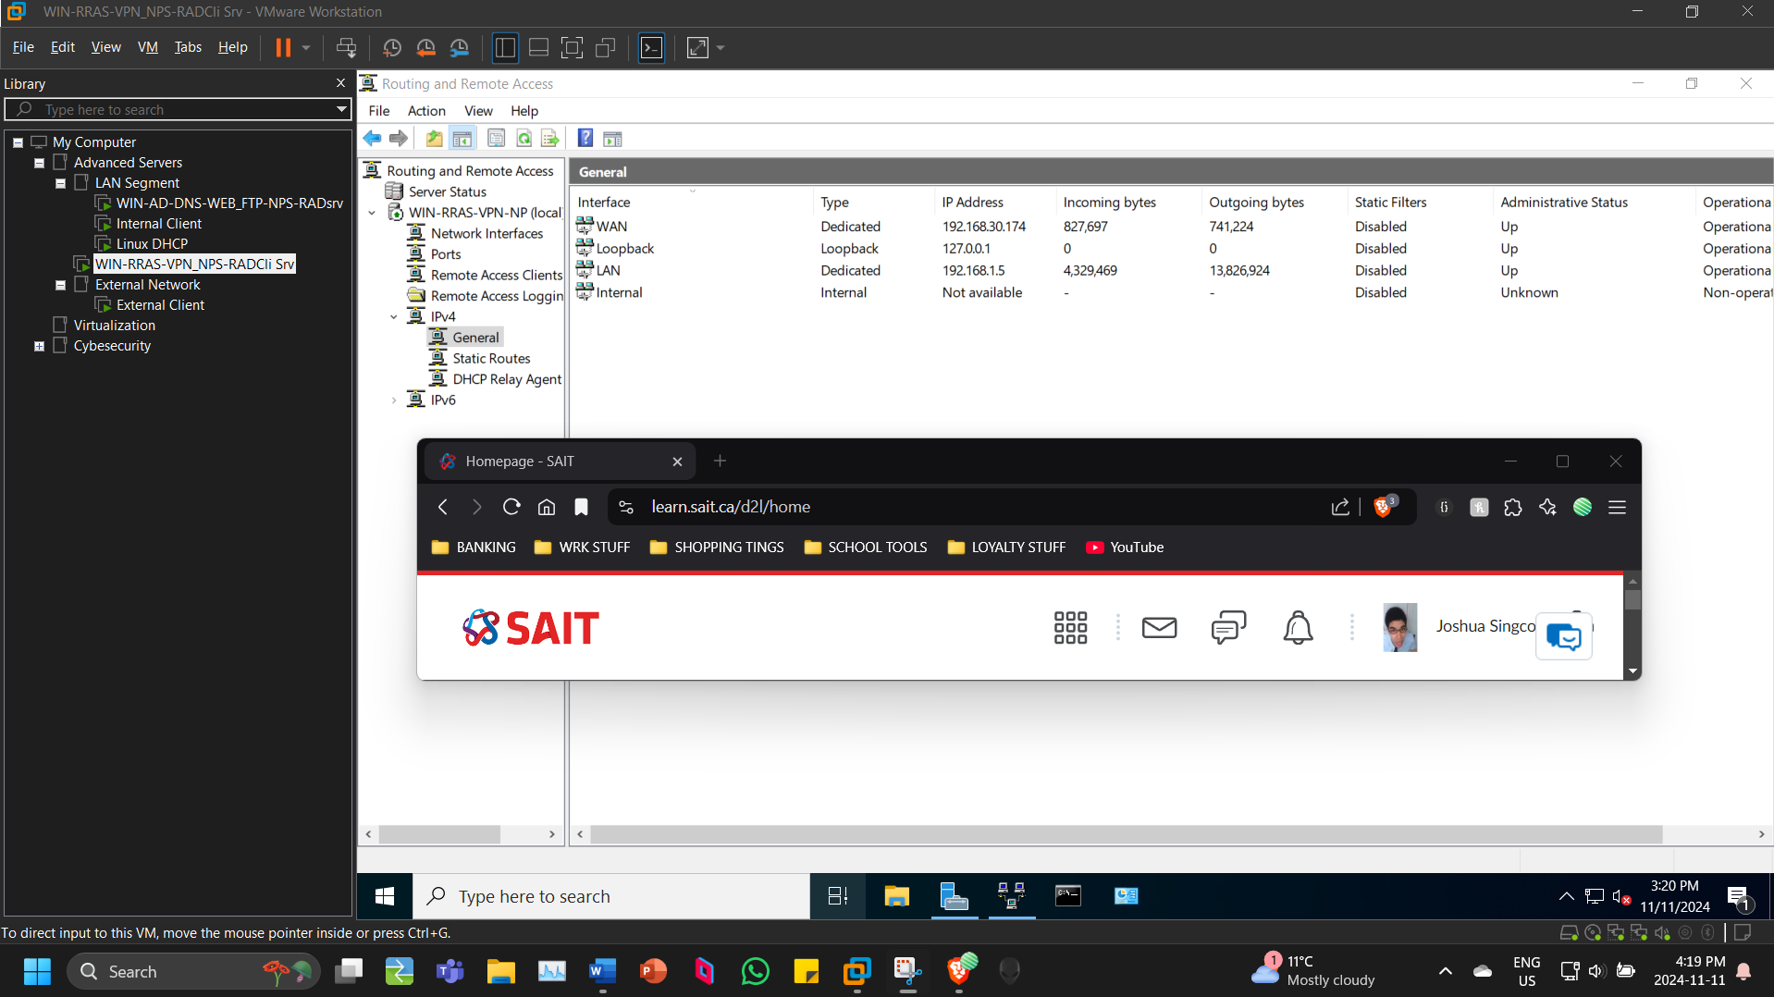

**Linux server**

* New DHCP scope configuration with changes to network reflected 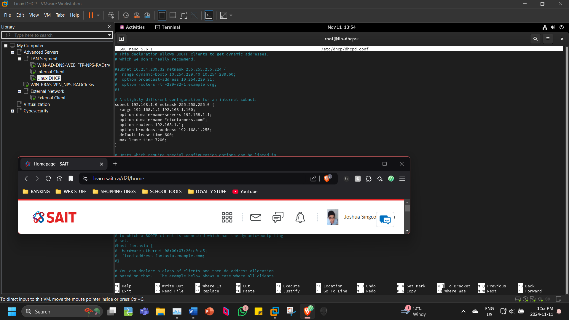

**Internal Client**

* ==When logged in as Erica==
  + Ipconfig /all outputA screenshot of a computer

    Description automatically generated
  + Accessing ftp
  + Being denied Accessing staff website
* ==When logged in as Trish==
  + Using browser to access staff website – including login prompt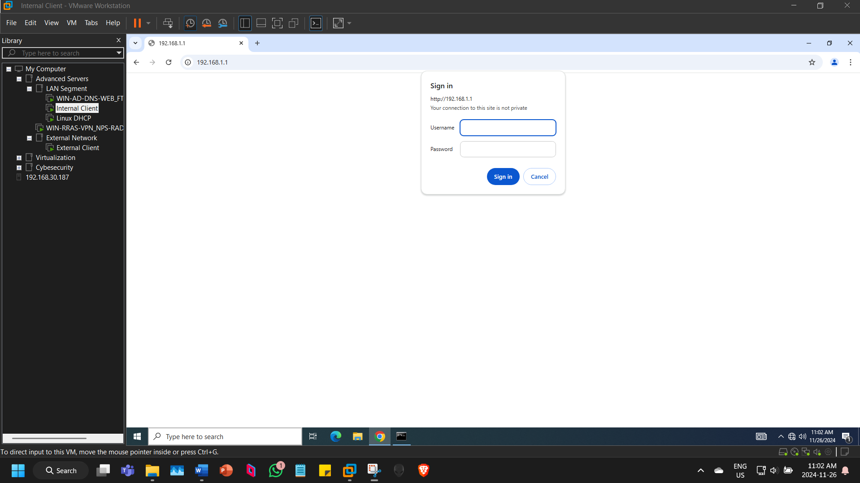
  + Successfully accessing www website – showing https:// connection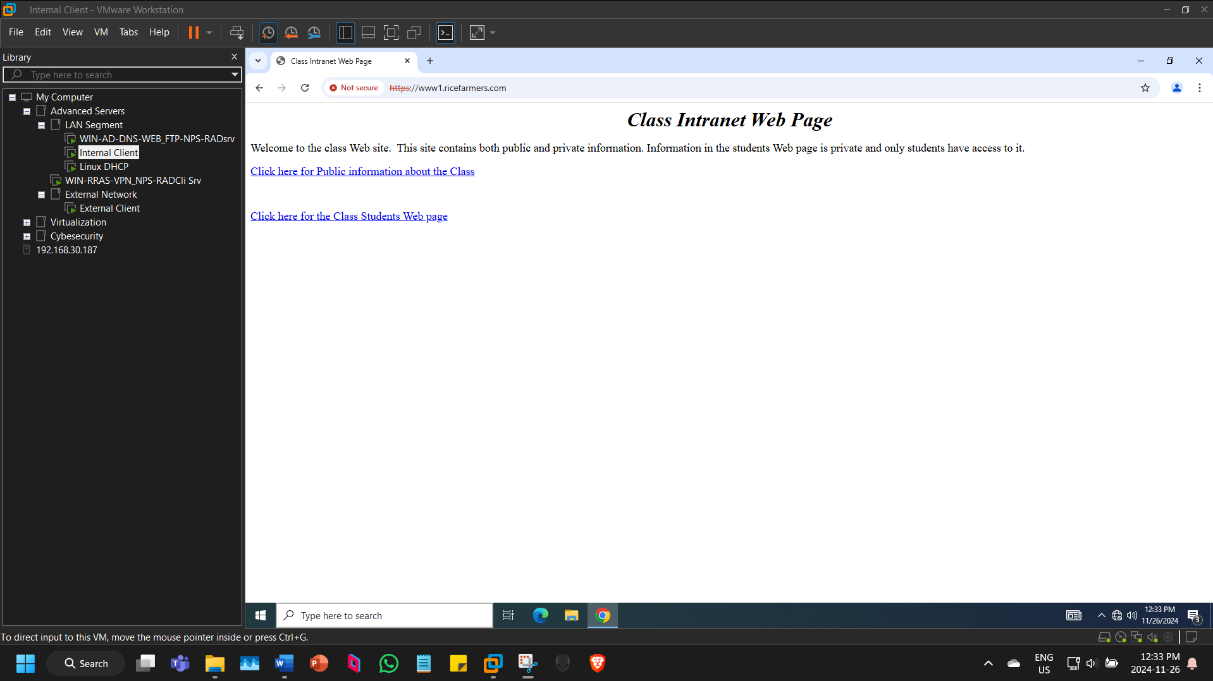
  + Able to access Internet site with browserA screenshot of a computer

    Description automatically generated

**External client**

* ==When logged in as Simon==
  + Successful VPN connection
  + Ipconfig /all when VPN connected
  + Hosts file
  + Accessing staff website
  + Accessing ftp site
  + Accessing honey share, able to read but without being able to write to it